Henkel
Functional Design Specification
SampleManager PhaseB

Document Reference | xxxx-FDS-SAMPLEMANAGER-B001
Version | 1.0
Last updated by | Zhenjuan.Zhang
Template Version | 1.0-0
Date
Status | Draft

chuxiaDocument Signoff
Name | Position | Company | Signature | Date

Table of Contents
Contents
1 Table of Contents 3
2 Introduction 5
2.1 This Document 5
2.1.1 Document overview 5
2.1.2 Disclaimer 5
2.1.3 Purpose 5
2.1.4 Scope 5
2.2 Synopsis 5
2.3 Definitions 5
2.4 References 6
3 Project Brief 7
3.1 Project Overview 7
3.1.1 Project detail 7
3.2 Functional Requirements 7
3.2.1 Sample Management 7

Version Management
Version | Description | Name | Date
1.0 | Created | Zhenjuan.Zhang

Introduction

This Document

Document overview
This document describes the system functionality of Phase B pilot stage covered in the Henkel QCLad System RTM User Requirements Analysis Report.

Disclaimer
The screenshots used below are screenshots generated during the system standard functions or system configuration, as well as customer sample screenshots, the final design may be different from the screenshots in the document, and the data on the screenshots is not the real data of the system, only for reference.

Purpose
This document is used to provide a detailed description of the functionality of the SampleManager system, identifying a description of the system functionality that meets the user's business needs as specified in the phase B pilot stage of User Requirements Analysis Report. The functionality of phase A, which is already deployed in the system, will not be described further

Scope
- Document the functional specifications of the laboratory management system based on the requirements described in the User Requirements Analysis Report.
- Determine the implementation of functionality in the system based on the needs described in the user needs analysis report

Synopsis
The core application functionality of the QCLad system is the laboratory sample process management functionality, including sample management, SAP interface, task scheduling, master data, reporting, architecture and security.;

Definitions
The following abbreviations and definitions are assumed throughout this document.
Term/  Abbreviation | Meaning | Description
FS | Function Specification | This Document
RMB | Right Mouse Button | Using RMB various Sample Manager options can be displayed
QCLAD | SampleManager | Software Name

References
The following references are made in this document.
Ref. No. | Reference | Description

Project Brief

Project Overview

Project detail
Implementation of SampleManager QCLad will streamline Sample Management, Reports, Dashboards, Instrument and Equipment management, Instrument interfacing and External application integration together with the associated data acquisition across Henkel’s labs.

Functional Requirements

Sample Management

Lab Testing Process Workflow

Business Scenarios
Generally, samples and tests will flow the process of workflow which is deployed during project stage phase A. In this document it will be referred to as the lab testing process and will be used in the lab as a base process for other subsequent workflows.

RTM Mapping

URS Ref. | Requirement | Type
4.1.5.1.1 | System shall be able to manage Standard RM test for Incoming workflow. （Standard RM） | Configuration
4.1.5.1.2 | System shall be able to manage Standard in process testing for semi finished and finished goods workflow. （without MES) | Configuration
4.1.5.1.3 | System shall be able to manage Standard finished goods outgoing test workflow. | Configuration
4.1.5.1.10 | System shall be able to manage Test for SCMS/NCMR /CCMS investigation workflow. | Configuration

Function Design
The lab testing process workflow defines the lifecycle of a sample from received status to authorization. See the flow chart below.
Samples and tests will be run according to this workflow if not otherwise specified.
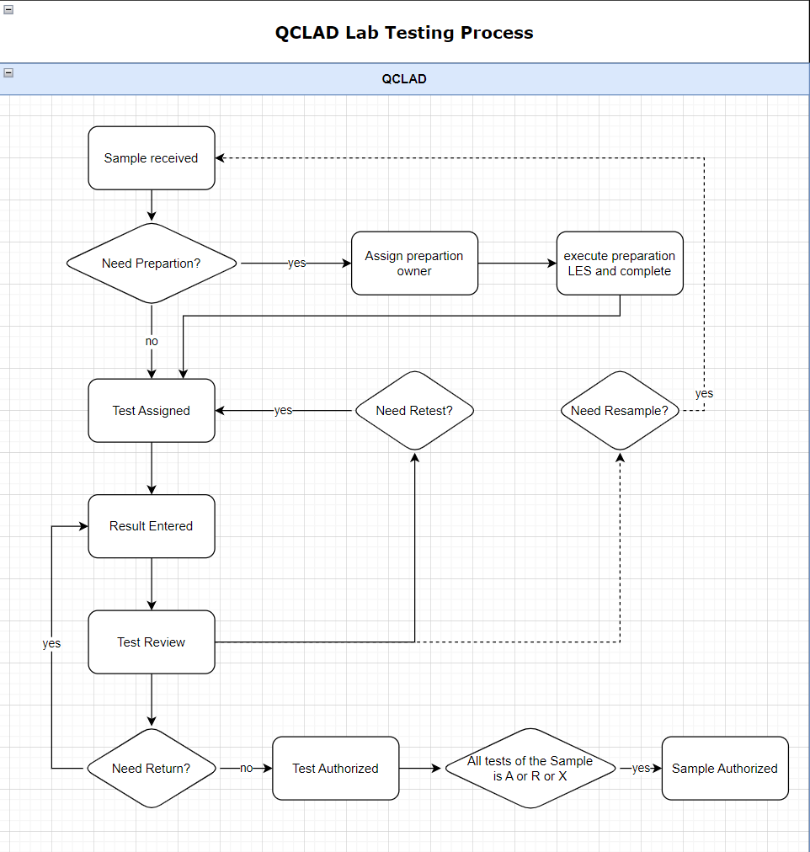

Truck Workflow

Business Scenarios
There are TRUCK samples that need to be created manually first, and then the sap inspection batch will be pushed. QCLAD needs to be able to return the results correctly.

RTM Mapping
URS Ref. | Requirement | Type
4.1.1.1.1 | System shall be able to login samples using configurable templates | Configuration
4.1.1.1.3 | System shall be able to create samples manually for standard testing. | Configuration

Function Design

Design Overviews
Users can create Tank samples and tests manually. QCLAD shall retrieve the results to SAP after inspection lot is received. (Based on RTM as above).
In the Sample management cabinet, samples and tests will be displayed in subfolders categorized by sample type. Truck sample will be grouped in sub folder IQC-TRUCK.

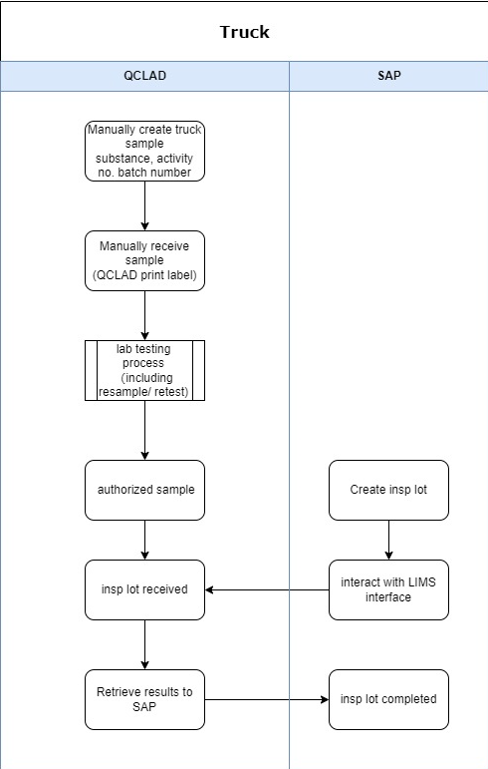

Process Design
Sample Login:
Truck Samples will be login by manually running sample login workflow Truck Sample by navigating to: Public folders-Sample Management-Create Sample.
The user needs to select the MLP and enter the batch number. QCLAD system will automatically fetch the IDH and activity number from the master data.
For truck material, creates the sample id by adding the entries.

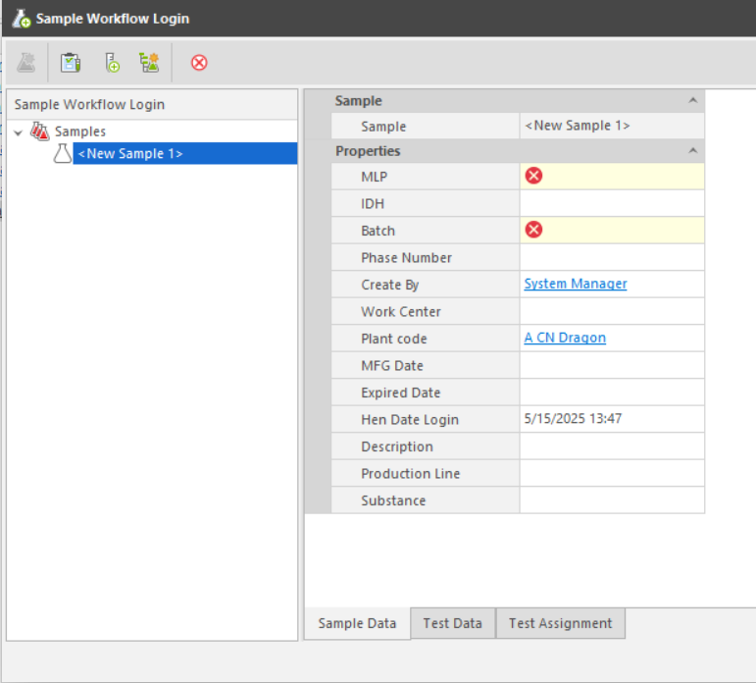
Properties in entity template clarification in LIMS:
No. | Properties | Type | Prompt Type | Description
1 | MLP | Identity | Mandatory | Links to MLP table
2 | Batch | Text | Mandatory | Batch id
3 | Plant code | Text | Optional | Links to Plant table
4 | Activity No | Numeric | Optional | Fetch from MLP
5 | Work Center | Text | Optional | Links to Work centre table
6 | Date Login | Date | Optional | Current date, modifiable.
7 | Create By | Operator | Optional | Current operator
8 | Description | Text | Optional | Descriptiom
9 | Substance | Identity | Optional | Fetch from MLP
10 | MFG Date | Date | Optional | Manufacture date
11 | Expired Date | Date | Optional | Expiration date
14 | Production Line | Identity | Optional | Fetch from MLP
Sample Receiving:
The user needs to find the specified sample from the New Sample Pending Receiving folder and right-click Receive Samples button to open the Sample Receiving window. After the sample is received, the sample label is automatically printed to the label printer in the corresponding work centre.
Sample Authorize:
When all tests for a sample are in the authorized or rejected status, the sample will automatically become authorized.
Authorized JIT samples will be listed in the Sample management-Authorized samples folder. System will highlight the JIT samples which has not received inspection lots from SAP by highlighting the background color in the Authorized samples folder.

Truck Samples are not automatically marked as waiting to be sent results to SAP when the sample is authorized, but need to wait for a response from the sap interface.

SAP interactive
Truck sample is created manually in QCLAD system.
When inspection lot created in SAP is pushed to QCLAD, interface would find the sample already existed in system and save the inspection lot number in the field ‘hen_inspection_lot’ and mark the field ‘hen_to_be_sent’ to true.

JIT Workflow

Business Scenarios
There are JIT samples that need to be created manually first. When all tests are all completed and reviewed, QCLAD will send the message which including sample decision information(A/R) to the MES. Then SAP will push the inspection lot and QCLAD needs to be able to return the results correctly.

RTM Mapping
URS Ref. | Requirement | Type
4.1.1.1.1 | System shall be able to login samples using configurable templates | Configuration
4.1.1.1.3 | System shall be able to create samples manually for standard testing. | Configuration

Function Design

Design Overviews
Users can create JIT samples and tests manually. QCLAD shall send the message to MES when sample is authorized and retrieve the results to SAP after inspection lot is received. (Based on RTM as above).
In the Sample management cabinet, samples and tests will be displayed in subfolders categorized by sample type. Truck sample will be grouped in sub folder IQC-JIT.

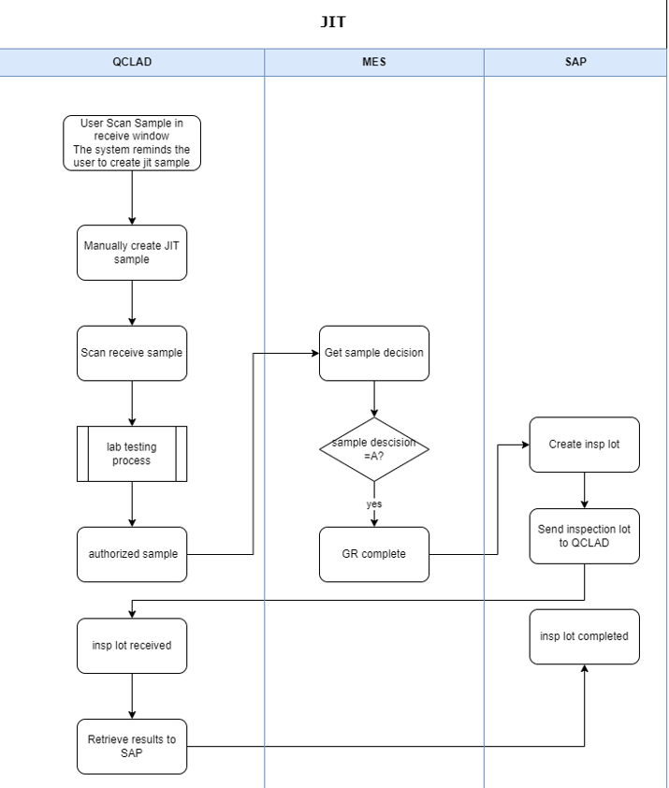

Process Design
Sample Login:
JIT Samples will be login by manually running sample login workflow JIT Sample by navigating to: Public folders-Sample Management-Create Sample
System shall remind user to create JIT sample when scanning receive the sample which has not yet been created in QCLAD
The user needs to select the MLP and enter the batch number. QCLAD system will automatically fetch the IDH and activity number from the master data.


Properties in entity template clarification in LIMS:
No. | Properties | Type | Prompt Type | Description
1 | MLP | Identity | Mandatory | Links to MLP table
2 | Batch | Text | Mandatory | Batch id
3 | Plant code | Text | Optional | Links to Plant table
4 | Activity No | Numeric | Mandatory | Activity number
5 | Work Center | Text | Optional | Links to Work centre table
6 | Date Login | Date | Optional | Current date, modifiable.
7 | Create By | Operator | Optional | Current operator
8 | Description | Text | Optional | Descriptiom
9 | Substance | Identity | Optional | Fetch from MLP
10 | MFG Date | Date | Optional | Manufacture date
11 | Expired Date | Date | Optional | Expiration date
14 | Production Line | Identity | Optional | Fetch from MLP
Sample Receiving:
Users can receive sample by scanning the MES label in sample receive window or manually finding the specified sample from the New Sample Pending Receiving folder.
After the sample is received successfully, the sample label is automatically printed to the label printer in the corresponding work centre.
The MES label should have a QR code that contains the information in the same format as phase A.
When a user scans to receive a JIT sample but the sample has not yet been created in QCLAD, system will remind the user in the scan window that the sample is a JIT sample.
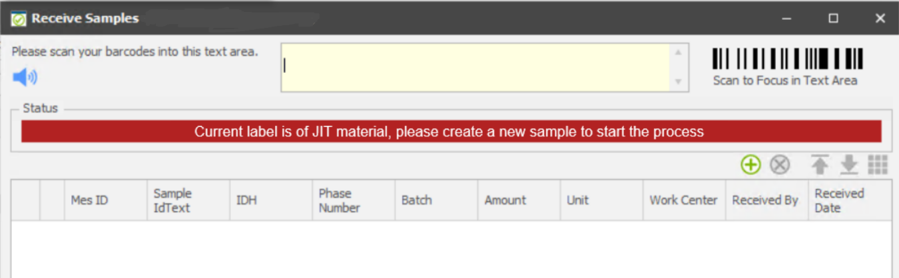
Sample Authorize:
When all tests for a sample are in the authorized or rejected status, the sample will automatically become authorized.
Authorized JIT samples will be listed in the Sample management-Authorized samples folder. System will highlight the JIT samples which has not received inspection lots from SAP by highlighting the background color in the Authorized samples folder.
JIT Samples are not automatically marked as waiting to be sent results to SAP when the sample is authorized but need to wait for a response from the sap interface.

SAP interactive
JIT sample is created manually in QCLAD system.
When inspection lot created in SAP is pushed to QCLAD, interface would find the sample already existed in system and mark it as waiting to be sent results.

MES interactive
When the sample is authorized, QCLAD determines the sample decision based on the on spec field on the sample table and sends a string to the MES interface.

